Clinical Guideline for:
Pre-operative Sedation Guideline for Children and Adults with Learning Disabilities: Northern Services
SUMMARY
The purpose of this document is to improve the prescribing and administration of sedative drugs used before general anaesthesia in children and adults with learning disabilities and challenging behaviour.
KEY POINTS
- The aim is to improve the use of sedative drugs in these groups and can be combined with other techniques to reduce pre-operative anxiety.
- The guideline will ensure that the administration of sedative drugs used before general anaesthesia in adults with learning disabilities are given in line with current legislation in regard to capacity and consent.
- The unfamiliar and threatening environment of the operating theatre can cause extreme anxiety in children and in particular children and adults with learning disabilities. The aim of preoperative sedation is to achieve a state of conscious sedation that facilitates the safe conduct of General Anaesthesia without the need to use physical restraint.
- The guideline applies to Anaesthetists and Nursing Staff involved in preparing patients for General Anaesthesia. The area most often affected is Day Surgery but this can also apply to inpatients on a General Ward or Intensive care.
- Implementation of this guideline will ensure:
- Safe prescribing and administration of sedative drugs used before general anaesthesia in children and adults with learning disabilities and challenging behaviour.
- A standardised approach in the use of premedication/sedation for children, adults and patients with learning disabilities.

CONTENTS

1. INTRODUCTION #
2. BACKGROUND #
3. DEFINITIONS #
4. MAIN BODY OF GUIDELINE #
Type chapter title (level 2) #
Type chapter title (level 3) #
5. MONITORING COMPLIANCE WITH THIS GUIDELINE #
6. ASSOCIATED CLINICAL GUIDELINES OR POLICIES/PROCEDURES #
7. PUBLICATION DETAILS #

1. INTRODUCTION

  - This clinical guideline is designed to provide advice, guidance and direction to staff whilst leaving room for professional judgement, and adaptation, to fit individual circumstances.

1.2 The purpose of this document is to improve the prescribing and administration of sedative drugs used before general anaesthesia in children and adults with learning disabilities and challenging behaviour.

2. BACKGROUND

  - The advantages of a pre-med are that it can reduce both patient and carer anxiety therefore improving the overall experience, it can provide amnesia and may reduce behavioural changes post operatively.
  - The advantages must outweigh possible disadvantages that would include worsening anxiety associated with administration of the medication, paradoxical reactions that can be seen e.g. midazolam and the potentiation of sedative side effects of drugs such as opioids.
  - The 2010 NICE guideline, “Sedation for diagnostic and therapeutic procedures in children and young people” [3] has been developed to assist the multidisciplinary team when an anaesthetic is required for children or adults with challenging behaviour. However the guideline does not specify specific medications to help with sedation.
  - This guideline has been developed to provide clarity on selecting sedative medication and managing children or adults once the sedative medication has been administered.

3. DEFINITIONS

Learning Disability
- According to the World Health Organisation ICD-10, a learning disability is a condition of arrested or incomplete development of the mind, with mild to profound impairment in cognition, language, motor and social skills [1].
- People with a learning disability may take more time to understand complex information and co-operate with others
- The level of care depends upon individual factors, including both the severity and the nature of their disability.

Sedation
- The American Society of Anaesthesiologists defines the continuum of sedation as follows [2]:
  - Minimal Sedation - Normal response to verbal stimulation
  - Moderate Sedation - Purposeful response to verbal/tactile stimulation. (This is usually referred to as “conscious sedation”)
  - Deep Sedation – Purposeful response to repeated painful stimulation.
  - General Anaesthesia – No response even with painful stimulus.
  - In the United Kingdom, deep sedation is considered to be part of the spectrum of general anaesthesia, as opposed to conscious sedation.

4. MAIN BODY OF GUIDELINE

Role of the Anaesthetist

The Anaesthetist is responsible for:
- Ensuring that preoperative sedative medication is prescribed correctly on the appropriate prescription chart, and where possible in line with the current guideline.
- Ensuring that the patient is in a safe environment, parents or carers are aware of the effects of any sedation administered.

4.2 Role of the Nurse
  - The designated Nurse is responsible for:
- Checking the prescription and preparing the sedative premedication.
- Ensuring that the premedication is safely and effectively administered.
- Communicate directly with the prescribing Anaesthetist if there are any problems with the prescription or administration of the drug/s.
- Maintaining a safe environment for the patient once sedation is administered which will include appropriate positioning and monitoring to avoid falls and unrecognised hypoxia.

Patients Requiring Sedation

Children or adults with special educational or behavioural needs e.g. Autism, Aspergers, Down’s syndrome

Children having major surgery

Children having repeated procedures

Children who have had a previous bad experience of the hospital environment

Children or adults with anxiety

Children with past history of stormy anaesthetic induction or emergence

These children should be identified preoperatively and referred to the Reasonable Adjustments Pathway.

Consent
  - Where sedation is to be administered, informed consent must be gained.
  - Where there is reason to doubt that the adult concerned has capacity to consent, a formal mental capacity assessment must be undertaken and recorded in the notes.
  - If the adult is assessed as not having capacity, then a decision should be made in their best interests. This should be the least restrictive option with reference given to local policy.
  - If preoperative oral or intramuscular sedation is planned then a discussion must occur with the patient (if appropriate) and/or the parents and carers beforehand. This discussion must cover the indication for premedication, the risks and benefits and in case of failure the plan for ongoing management of the patient. This discussion must be documented.
  - All children should be included in discussions regarding their health and treatment as much as possible given their level of comprehension.

Relative contraindications to sedative premedication:
  - Anticipated difficult airway
  - Increased aspiration risk
  - Obstructive sleep apnoea
  - Raised intracranial pressure
  - Acute systemic illness e.g. severe sepsis
  - Reduced SpO₂ on room air
  - Severe renal or hepatic impairment
  - Previous allergic or behavioural reaction to the premedication proposed

Administration
  - For the occasional child with extremely challenging behaviour, it may be appropriate to use up to three sedative drugs in combination under the direction of an Anaesthetist.
  - For some children it may be appropriate to use a dose in excess of the maximum dose stated below.
  - This should be prescribed and requested by a consultant Anaesthetist and clearly documented on the drug chart.
  - Care should be taken when prescribing in the overweight child, with consideration made regarding ideal body weight vs. actual body weight.
  - The oral preparations may be added to a small volume of flavoured squash to help with any unpleasant taste, i.e. dilute with an equal volume of squash.
  - If the child refuses, vomits or spits out the drug, or for any questions regarding a prescribed drug, please contact the Anaesthetist who prescribed the drug.
  - After receiving sedative medication, the child should remain on the ward under the direct supervision of a responsible adult, such as a parent or guardian.
  - When they become drowsy, they should lie in bed. If they fall asleep, oxygen saturation should be continuously monitored by pulse oximetry. Oxygen should not be routinely administered.

  - Sedative Medications
Drug | Route | Formulation | Age | Dose | Onset of action | Duration of action | Maximum dose
Clonidine¹ | oral | (use IV solution orally)  150 micrograms/ml  or  Tablets  25 or 100 micrograms | any | 4-5 micrograms/kg | less than 1 hour | 6-8 hours | 300 micrograms
Dexmedetomidine² | intra nasal | 100 micrograms/ml  Solution for injection may be administered via these routes – this is not within the product license | any | 1-2 micrograms/kg | 30 - 45 minutes | 1-6 hours | Use MAD device to deliver drug
 | buccal |  | any | 1-4 micrograms /kg | 10-15 minutes | 1-6 hours | May have prolonged recovery due to duration of action  Bradycardia is common
 | oral |  | any | 4 micrograms /kg | 30 - 45 minutes | 1-6 hours
Midazolam^{3,4,5} | oral⁸  (Ozalin) | Oral solution 2mg/ml | any | 0.25 mg/kg | 20-30 minutes | 1-6 hours | 20 mg³
 | oral  (IV solution) | IV solution | any | 0.5 mg/kg | 20-30 minutes | 1-6 hours | 20 mg³
Ketamine^{5,6} | Oral | 50mg/ml  Solution for injection may be administered via these routes – this is not within the product license | >1 year | 5-10 mg/kg | 20-30 minutes | 1-2 hours
 | intra nasal |  | >1 year | 5-10 mg/kg | 10-15 minutes | 1-2 hours
 | intra muscular |  | >1 year | 5 mg/kg | 5 minutes | 1-2 hours
Ketamine with Midazolam | Oral |  | >1 yr | Ketamine 3-5mg/kg  Midazolam as above | 20-30 mins | 1-6 hours

  - Notes

  - The 100 microgram Clonidine tablets can be crushed and dispersed in water. This can be considered to minimise the volume of liquid.
  - Dexmedetomidine is shorter acting than clonidine, has little if any respiratory depression, is easy to administer intranasally and is not as irritant as midazolam. IV Dexmedetomidine is available from the drug cupboard in theatre 6.
  - Oral midazolam can be increased above the recommended maximum dose but this is the sole responsibility of the Anaesthetist concerned.
  - Ketamine can be mixed and given with midazolam at the dose described above.
  - Dexmedetomidine can be mixed and given with midazolam at the doses described above.
  - Ketamine is a good analgesic but is hallucinogenic and patients should be recovered in a relatively quiet and non-stimulating environment. The IV solution is available from the theatre 6 Controlled Drug cupboard.
  - If asked to prescribe a premedication in order to facilitate attendance for surgery. This is not a usual process and should undergo an MDT discussion prior to consideration. Alternative strategies should be sought, such as desensitisation.
  - Oral Midazolam (Ozalin®) comes in a pack including an ampoule of 10mg/5ml, drawing up straw and syringe. The syringe that has graduations based on patient weight. Physicians prescribe the dose as per normal practice and the nursing staff have undergone training to dispense correctly.

4.9 Appendix 1: Sedative Premedication Flow Chart

Advantages | Disadvantages
- Reduces both patient and parental anxiety and improves overall satisfaction with the experience  - Provides ante grade amnesia  - Reduces postoperative behavioural changes and adverse outcomes in children | - Noncompliance by the child may worsen anxiety  - Paradoxical reaction may be seen in response to some drugs e.g. Midazolam  - May potentiate the effect of other sedative drugs
Indications | Contraindications
Need for sedative premedication should be part of pre-anaesthetic assessment of any child or adult with special needs. The following patients are likely to benefit from premedication.  - Children or adults with special educational or behavioural needs e.g. Autism, Aspergers, Down’s syndrome  - Children having major surgery  - Children having repeated procedures  - Children who have had a previous bad experience of the hospital environment  - Children or adults with anxiety  - Children with past history of stormy anaesthetic induction or emergence | The following are some conditions where a careful risk assessment must be made prior to prescribing sedative premedication  - Anticipated difficult airway  - Increased aspiration risk  - Obstructive sleep apnoea  - Raised intracranial pressure  - Acute systemic illness e.g. severe sepsis  - Reduced SpO2 on room air  - Severe renal or hepatic impairment  - Previous allergic or behavioural reaction to the premedication proposed
Practical considerations
- Confirm fasting status (refer to fasting guidelines for all patients having an anaesthetic at NDDH)
- Discuss with the parents or carers of the child/patient (where appropriate) and document what they can expect from the premedication
- Prescribe the premedication on the drug / anaesthetic chart, including route dose and time when it should be administered (different drugs have variable onset times see chart below)
- Inform the preoperative / day surgery nurse responsible for the patient that a “premed” has been prescribed to ensure that it is given at the appropriate time.
- Oral premedication drugs can be given mixed with a small volume (5-30ml) of clear solution (e.g. ribena, orange juice or paracetamol mixture) which the child usually accepts to mask the unpleasant taste
- Sedative drugs should be provided in a safe environment where resuscitation equipment and drugs can be accessed
- A sedated child / adult should be appropriately monitored at all times.

Tips and trouble shooting
- Oral midazolam has a quick and reliable onset and is most frequently used at NDDH
- Oral midazolam (Ozalin) does not have an unpleasant taste unlike the tradition Buccal Midazolam.
- Oral midazolam may be combined by the anaesthetist with dexmedetomidine or clonidine for a longer duration of action.
- Oral midazolam can be combined with oral ketamine for a quicker onset.
- Oral / Intranasal dexmedetomidine is also an alternative to oral midazolam. Its onset of action is slower.
- Beware additive sedative effects and consider dose reduction.
- In children with previous emergence agitation or paradoxical reaction to midazolam, clonidine or dexmedetomidine given either as a premedication or intraoperatively, may have a beneficial effect.
- Intranasal /transmucosal (buccal) route often has a quicker onset and may be used when oral premedications are refused, keeping in mind that trying the intranasal route in a distressed child may pose a risk of injury to staff and child (beware that absorption from the intranasal route may be variable)
- Ozalin® is a licensed product for oral administration. It is given at a dose of 0.25mg/kg by an oral syringe. It does not have a bitter flavour and so can be given without juice.
- Use a MAD (mucosal atomizing device- available in theatre 6) and a 2ml syringe to deliver the drug effectively and safely when using the intranasal route
- Intra muscular drugs (Ketamine) may be used as an alternative in noncompliant children / patients if premedication is felt necessary (see footnote on use of Ketamine intramuscular injection)
- It is not normal practice that a sedative is prescribed prior to coming to hospital. Alternatives should be sought (such as desensitization) and an MDT should be undertaken so that shared decision making can be undertaken in the best interest of the patient.

Suggested Pathway for Choosing Sedative Premedication in Children

Sedative Premedication Required?
- Buccal Dexmedetomidine 1-4 micrograms/kg
- Intranasal Dexmedetomidine 2 micrograms/kg
- Intramuscular Ketamine 5 micrograms/kg
No
Yes
Is the child compliant with oral premedication
- PO Midazolam 0.25 mg/kg or PO Dexmedetomidine 4 micrograms/kg
- PO Midazolam 0.25 mg/kg + PO Dexmedetomidine 4 micrograms/kg for a longer duration
- PO Midazolam 0.25 mg/kg + PO Ketamine 5 mg/kg for quicker onset
- PO Midazolam 0.25 mg/kg + PO Clonidine 2-3 micrograms/kg for a longer duration
  - Appendix 2: Ketamine Intramuscular Injection
  - Ketamine may be administered by intramuscular injection to patients in whom administration of oral premedication has failed.
  - Intramuscular ketamine has a quicker onset of action (seconds to minutes).
  - The administration of intramuscular ketamine must be discussed with the child/parent/carer and this discussion should be documented.
  - The discussion should include alternative courses of action, a plan for administration, and the immediate effects of ketamine.
  - Prepare the “Ketamine intramuscular injection” to a dose of 5mg/kg in a 5ml syringe with a 23-Gauge needle attached.
  - The parents should hug or distract the child, ideally seated or lying down and consideration should be given to the use of the “Sensory Unit” and play specialists.
  - Ketamine can be effectively administered in one of the side rooms on the day surgery unit or in the anaesthetic room.
  - Keep the patients shoulder (deltoid), thigh (vastus lateralis) or buttock (ventrogluteal) exposed if possible.

4.11 Appendix 3: Mucosal Atomizer Device (MAD)
  - Use the MAD device to administer 2 micrograms/kg of Dexmedetomidine neat (100 micrograms/ml)
  - Intranasal dexmedetomidine may be challenging to deliver to patients who are already anxious and unable to tolerate oral medications The administration of intranasal dexmedetomidine must be discussed beforehand with the child/parents/carers and team and this discussion must be documented. The discussion should include alternative courses of action and a plan for administration.
  - A 2ml syringe is generally the right size to use, and make sure that the sponge is gently but firmly nestled in the nostril to avoid shooting the device across the room.
  - A short sharp expulsion of drug from the syringe ensures that the liquid is optimally atomized.
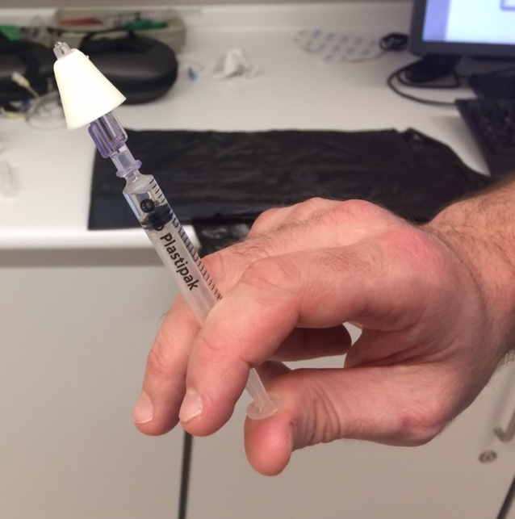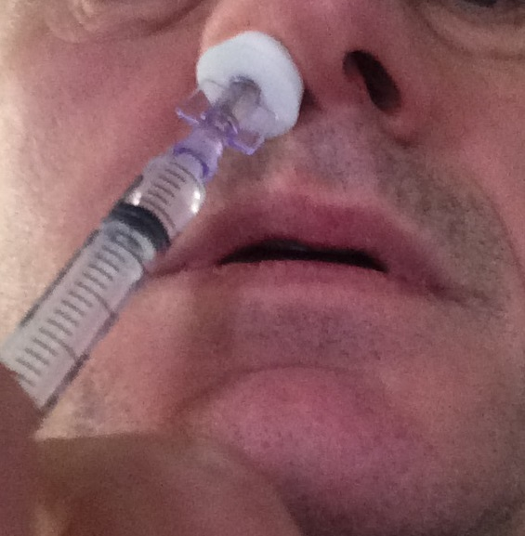

5. MONITORING COMPLIANCE WITH THIS GUIDELINE

Standards/Key Performance Indicators
  - Adequate sedation and compliance for anaesthesia in children or adults with learning disabilities
  - Improved pre-operative sedation in the target groups as reported by the Anaesthetic team

Process for Implementation and Monitoring Compliance and Effectiveness
  - A presentation will be given to anaesthetists and theatre staff detailing the guidelines
  - Guideline printout/summary to be available in the Day Surgery anaesthetic room, where children and those with learning disabilities are most likely to be anaesthetised
  - Guidelines will be available on the hospital Intranet
  - Monitoring process:
- A questionnaire regarding premedication and sedation prior to anaesthesia will be performed prior to presenting the new guidelines, and repeated as part of an audit cycle after their first initiation.
- This audit will be carried out and will be reviewed on a yearly cycle.
- Audit will include review of medications as recommended by NICE, and feedback from the anaesthetic and theatre teams.

6. ASSOCIATED CLINICAL GUIDELINES OR POLICIES/PROCEDURES

- Sedation in under 19s: using sedation for diagnostic and therapeutic procedures, [CG112] NICE guidelines 2010.
- J. Short, A. Calder Anaesthesia for children with special needs, including autistic spectrum disorder. Continuing Education in Anaesthesia, Critical Care and Pain Jan 2013.
- W. Funk, W. Jakob, T. Riedl, K.Taeger Oral preanaesthetic medication for children:double blind randomised study of a combination of midazolam and ketamine vs midazolam or ketamine alone BJA 84(3): 335-40 (2000)
- N. Almenrader, M.Passariello, B.Coccetti et al Premedication in children: a comparison of oral midazolam and oral clonidine Pediatric Anesthesia 2007 17:1143- 1149
- Paediatric Clinical Practice Guideline, Royal Alex Hospital, Brighton, 2016.
- Paediatric Formulary, 8th Edition, Evelina Children’s Hospital.
- Dexmedetomidine: perioperative applications in children. Pediatric Anesthesia. 2010; 20:256-264
- NDHT Medicines Policy (2018) http://ndht.ndevon.swest.nhs.uk/medicines-policy/
- NDHT Covert Administration of Medicines SOP (2019) http://ndht.ndevon.swest.nhs.uk/covert-administration-of-medicines-standard-operating-procedure/
- NDHT Unlicensed Medicines Policy (2018) http://ndht.ndevon.swest.nhs.uk/unlicensed-medicines-policy/
- Mental Capacity Act (2005) code of practice and North Devon Healthcare Trust Mental Capacity Act policy. http://ndht.ndevon.swet.nhs.uk/mental-capacity-act-policy/
- Consent Policy, North Devon Healthcare NHS Trust, March 2012 http://ndht.ndevon.swest.nhs.uk/2012/04/consent-policy/

7. PUBLICATION DETAILS
Author of Clinical Guideline | Dr Robert Conway  Dr Debbie Sanders
Division/ Department responsible for Clinical Guideline | Surgery, Northern Services
Contact details | rob.conway@nhs.net
Version number | 3.2
Replaces version number | 2.0
Date written | January 2018; reviewed September 2022
Consultation undertaken with: | • North Devon Anaesthetic Governance  • North Devon Surgery in Children Governance  • Anaesthetic Staff including Paediatric Anaesthetic Lead  • Day Surgery including Jane Dickinson, Reasonable Adjustments Pathway Liaison  • Paediatric Staff  • Nursing Staff  • Pharmacists  • Adult Learning Disability Liaison Nurse  • Adult and Paediatric Safeguarding
Approving body and date approved | North Devon Surgery in Children Governance, October 2022
Review date | June 2025 (3-6 months prior to expiry date)
Expiry date | 01/09/2025
Date document becomes live | Date document is published on IaN

